**Resume**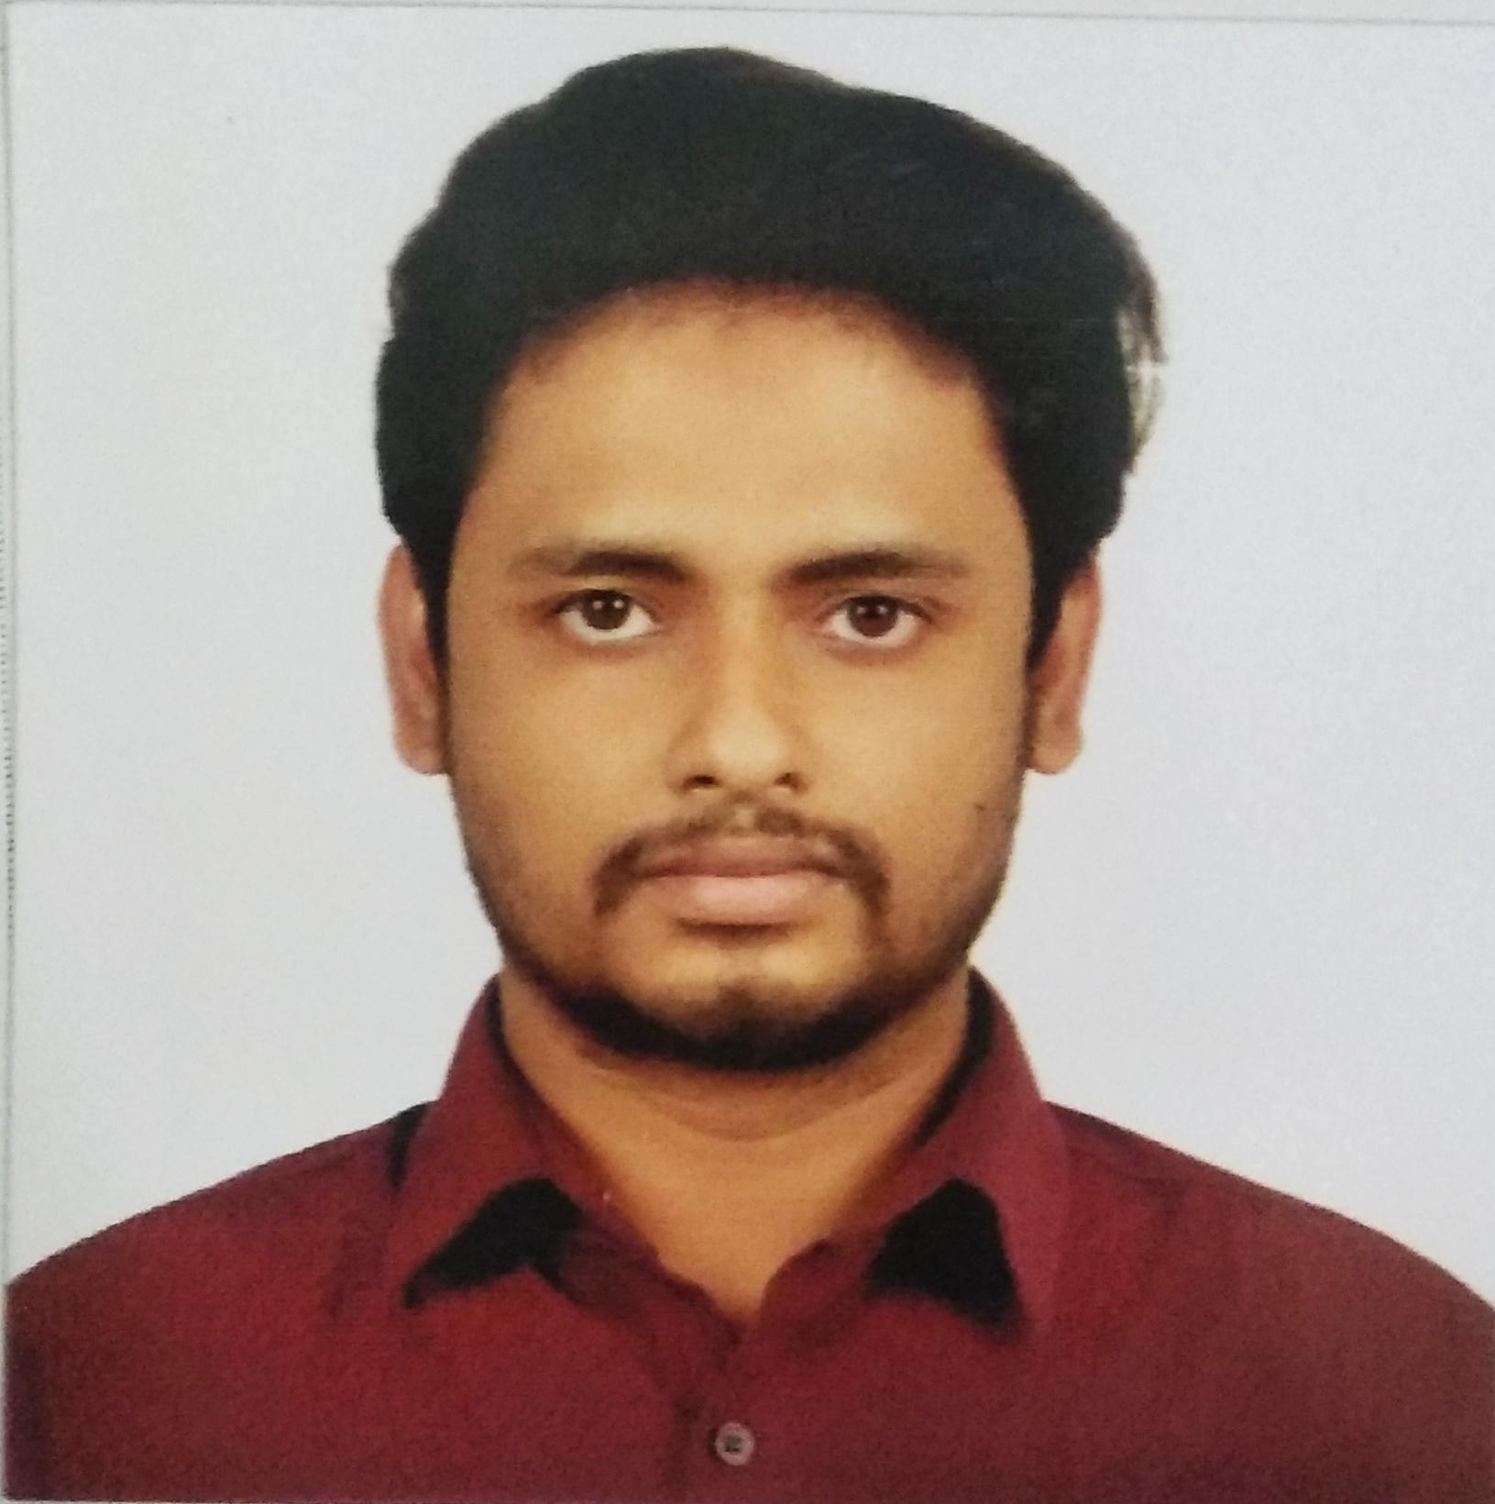

**Of**

**RIYAD HUSSAIN**

Lane-08, Road No: 02 Sylhet-3100

Contact no: **01789918991**

E-mail: [riyadhussain456@gmail.com](mailto:riyadhussain456@gmail.com)

**Objective**

To develop my career in a well reputed industry or organization with honesty and dignity where I can use my interpersonal skills, creativity and above all my learning with working experience and where there is scope to gather knowledge and contribute as well.

**Education**

**2013– 2017 SOUTHEAST UNIVERSITY DEPARTMENT OF PHARMACY**

B. Sc. (Hon’s) in Pharmacy 160 Credits Earned (Out Of 160 Credits)

Result: CGPA: 3.23 (Out of 4.00)

**2011** **Sylhet M.C College**

Sylhet Board

H.S.C., Science

Result: GPA - 4.80 (Out of 5.00)

**2009** **Sylhet Govt. Pilot High School**

Sylhet Board

S.S.C., Science

Result: GPA- 5.00 (Out of 5.00)

**Experience**

**Company : Silco Pharmaceuticals Ltd.**

**Duration : : 1 September 2018- 30 March 2020**

**Designation :** Q.A Officer

**Location :** Khadimnagar, Sylhet

**Computer Skills**

**MS OFFICE** MS Word, MS Excel, MS Power Point, MS Outlook.

**Language Skills**

**ENGLISH** Fluent in Speaking, Writing and Listening.

IELTS Score- 6.0

**BANGLA** Fluent in Speaking, Writing and Listening

**Personal Information**

|  |  |  |
| --- | --- | --- |
| O | **Name** | Riyad Hussain |
| O | **Father’s Name** | Rafiqul Islam Pathan |
| O | **Mother’s Name** | Begum Forida |
| O | **Permanent Address** | Vill: Ghonia, P.O. Faridgonj, Dist: Chandpur. |
| O | **Date Of Birth** | 14/02/1994 |
| O | **Religion** | Islam |
| O | **Nationality** | Bangladeshi (By Birth) |
| O | **Marital Status** | Unmarried |
| O | **Height** | 5’08’’ |

**Reference**

Dr. Md. Siddiqul Islam

Chairman department of pharmacy

Southeast University

M.O: 01914726253

**E-mail:** [**siddiquepharmacy@gmail.com**](mailto:siddiquepharmacy@gmail.com)

**DECLARATION**

I hereby declare that the information furnished above is true to the best of my knowledge.

-----------------------

**(Riyad Hussain)**